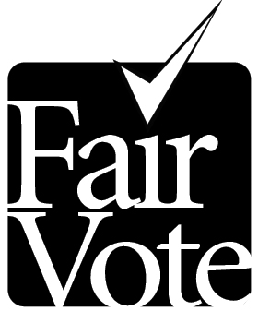
The Center for
Voting and Democracy

6930 Carroll Ave., Suite 610
Takoma Park, MD 20912 - (301) 270-4616
(301) 270–4133 (fax) ·info@fairvote.org
www.fairvote.org

Making Youth Voter Pre-Registration Programs Work
Lessons from Hawaii and Florida

In 2009, George Mason University professor Michael P. McDonald secured funding from the Pew Charitable Trusts to study voter preregistration and implementation tactics in the two states with a pre-registration age of 16: Hawaii, where it became law in 1993 and Florida, where it passed in 2007. Dr. McDonald’s key finding is that voter pre-registration seems to have a measurable impact on voter registration when certain actions are taken to reach out to young people.

Here are successful elements of these states’ voter pre-registration programs.

- In Florida, Supervisor of Elections staff came to schools for one day and conducted registration drives through individual classroom visits or school-wide assemblies.
- Student groups (such as Student Government Associations) and teachers have conducted their own drives on a volunteer basis, after being trained by election staff.
- At registration drives, students can be given “I registered” stickers or other paraphernalia to show their pride and encourage others, including their parents, to register and vote.
- Registration forms can be made available in school and public libraries and other public venues, without any active encouragement.
- Officials can mail forms to students eligible for pre-registration by using the school rosters and enclosing registration forms with handouts that most students receive (like diplomas)
- In Hawaii, election officials have mailed registration forms to every eligible student, coordinated with volunteers to organize registration drives (schools are not required to participate), and worked with larger efforts similar to Rock the Vote to conduct assemblies.

Key Findings

- In Florida, numbers of pre-registrants increased to 78,000 in 2008 as schools do more and more to encourage and inform their students.
- In Hawaii, full use of its procedures resulted in a return rate of about 30 percent for in-school efforts compared to four percent from mailings alone.
- Face-to-face engagement of students that requires as few active efforts as possible seems to maximize results.
- Tracking return rates is useful in analyzing best practices, costs, and improvements.

