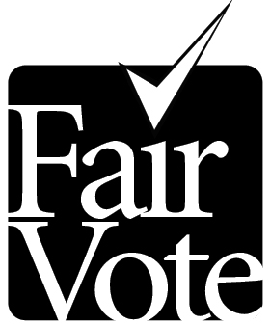
6930 Carroll Ave., Suite 610
Takoma Park, MD 20912 - (301) 270-4616
(301) 270–4133 (fax) ·info@fairvote.org
www.fairvote.org
The Center for
Voting and Democracy

VOTER PRE-REGISTRATION: A SENSIBLE INNOVATION
The oft-repeated myth is that young people don’t vote. But it’s not quite true. Young people in major elections often vote in comparable rates to older citizens when they’re registered, but they tend to be registered at much lower rates. A significant disparity exists between the percentage of young people registered to vote and the percentage of the general population. As of 2008, 71% of eligible voters were registered; 59% of eligible voters age 18-24 were registered.

To help address this problem, Hawaii, North Carolina, Rhode Island, Washington, D.C., Oregon, California, Puerto Rico and Maryland have all implemented some form of youth voter pre-registration: most establishing a uniform voter pre-registration age of 16. Lack of uniformity in voter registration age (depending on when the next general election will occur) creates confusion and undercuts effective voter ed programs in schools and at the DMV. Allowing pre-registration at age 16 make sense, as that is when many people get their drivers licenses, and they could pre-register to vote at the DMV. In addition, 16-year-olds still have to attend school, so they have the chance to register in effective school programs. And of course pre-registration does not change the voting age. Local and state jurisdictions can lower the voting age if they so choose, but it is a separate question from voter registration.

Here are quotes about voter pre-registration:
.
“There is no better place to challenge the expectation of nonparticipation than in our high schools. Nearly every citizen enters high school too young to vote and leaves eligible to vote. Yet most students today leave without registering or obtaining even rudimentary information about how to vote.”
-Rob Richie, Executive Director of FairVote

“Following the procedures described in the legislation, I believe we can maintain the security and integrity of our elections and provide additional access for young people to the voting process.”
-Gary Bartlett, Executive Director of the NC State Board of Elections, 2009

“[Florida and Hawaii] pre-register tens of thousands of eligible young people who remain on the voter rolls at rates comparable to the adult population. Pre-registration appears to have a modest positive stimulative effect on voter turnout.”

- Michael McDonald of George Mason University in 2009 report analyzing the effects of voter pre-registration
“It's good politics. It's good government. It's just the thing we ought to be doing.”

- Kelda Helen Roys, Wisconsin State Representative, 2009

